BUG 1:

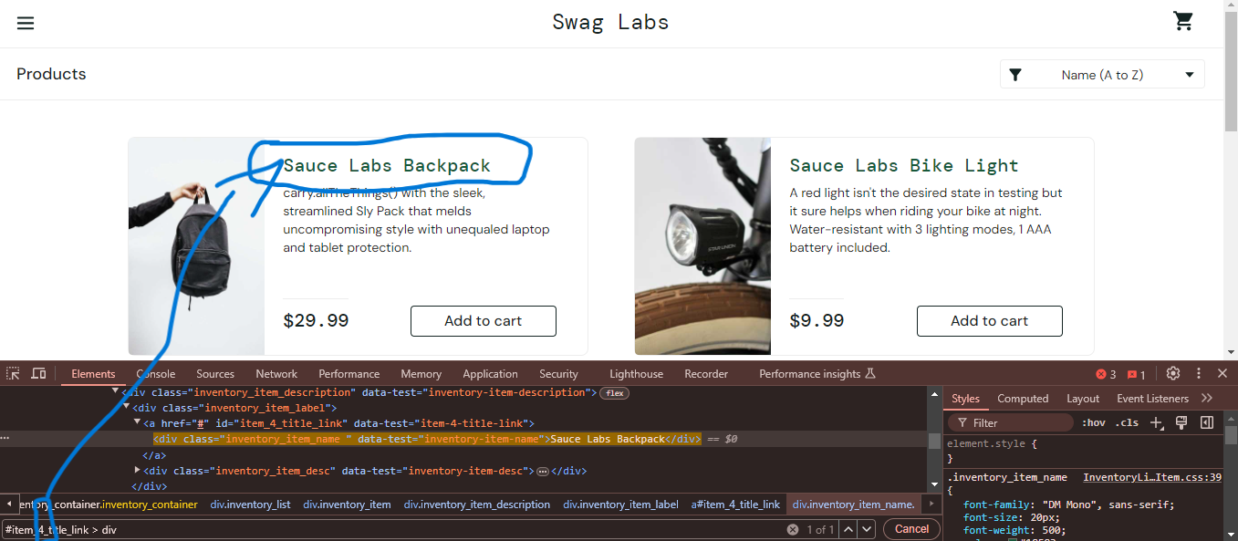

Products not arrenging perfectly. For example use for css selector number is 4, but the product

Is arrenged in first place.

BUG 2:

Codes not effectively. And Product not open new window

BUG 3:

Product clickable not efficient, some place clickable, So this webpage not prepare to

Smart phones.